How to Operate Transmission Contest Test Apparatus

## Updated by Melissa Tanner, [mmtanner@caltech.edu](mailto:mmtanner@caltech.edu), May 2014

1. **Log on to the computer next to the transmission contest apparatus.**

username: shopuser password: shopuser

1. **Open “Transmission.vi” in LabVIEW.**

Click on the Start button > LabVIEW > Transmission.vi (pinned to the taskbar). OR Desktop > Transmission Contest > Transmission.vi. Select “Launch LabVIEW”.

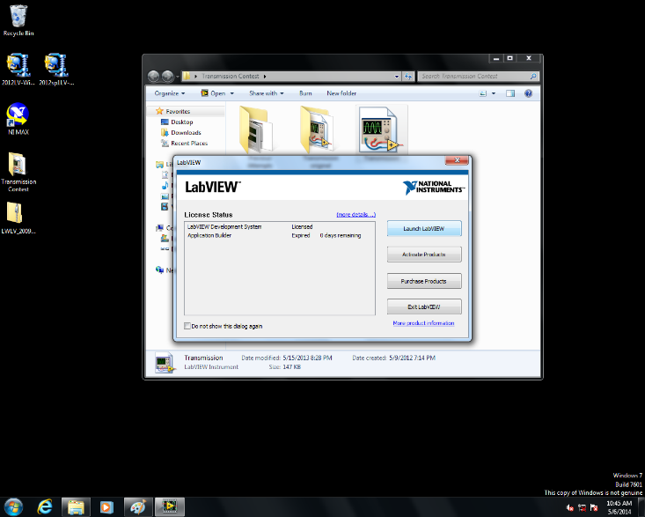 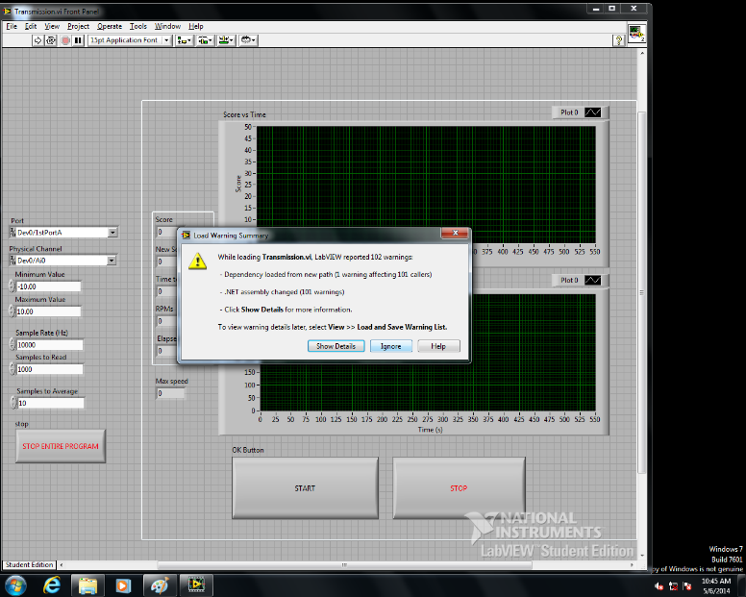

A warning message may appear; select “Ignore”.

1. **Click "run" (the arrow in top left hand corner).**

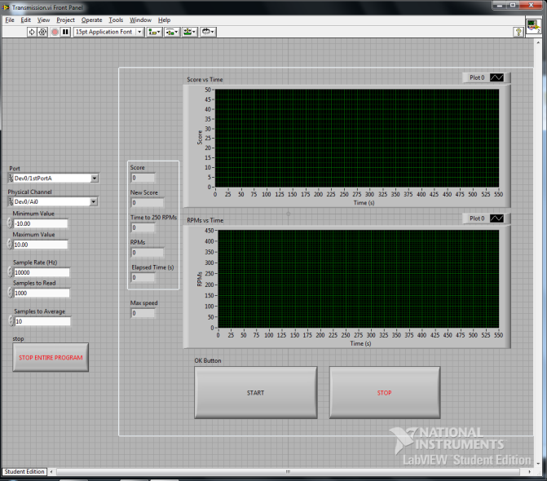 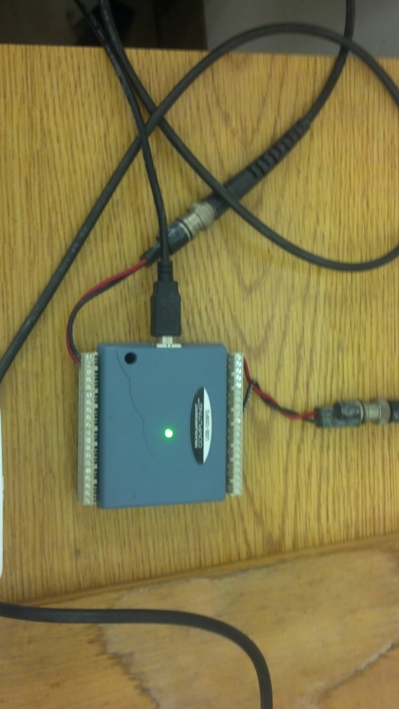

If an error message pops up, check that the DAQ has a solid green light. If the LED is blinking, disconnect the USB plug, and plug it in again.

1. **Secure your transmission in the test rig.**

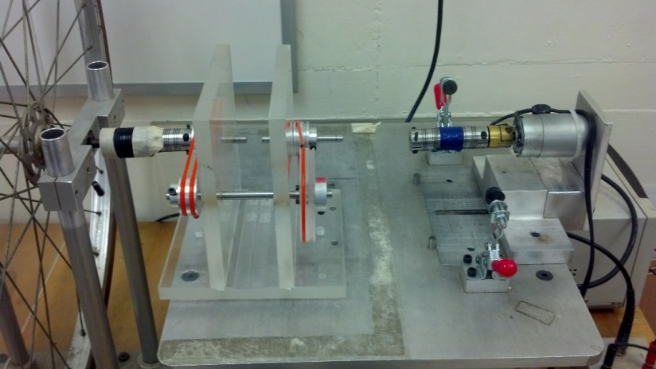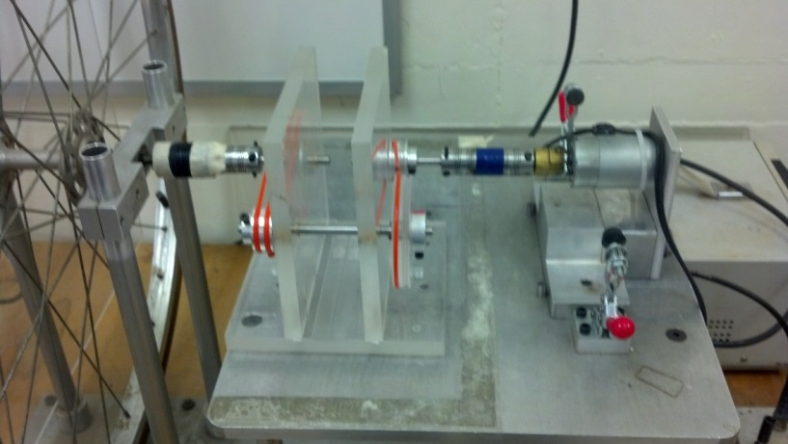Unclamp the motor and slide it out to make room for your transmission. Place your transmission on the table, and slide its shaft onto the left coupling. Slide the motor back into place, affixing the right coupling on your transmission’s shaft.

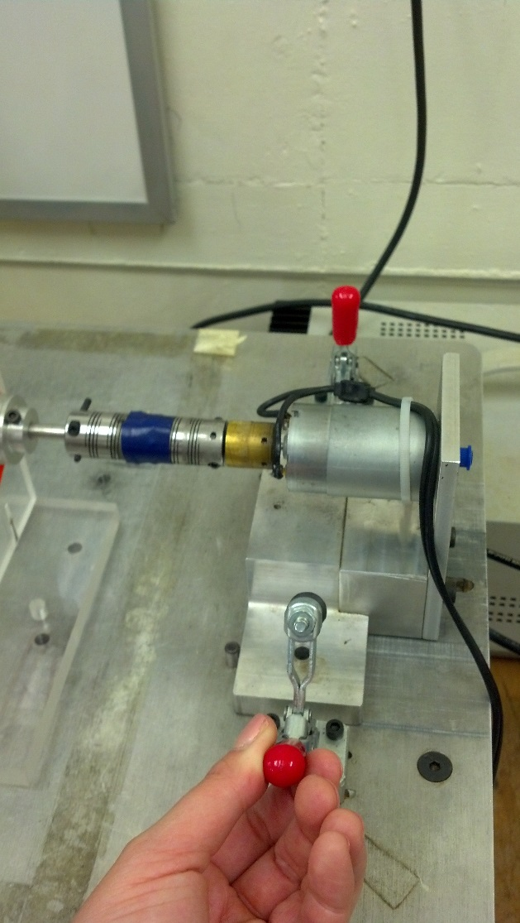Clamp down the motor, tighten the screws on the couplings, and anchor your transmission to the table. Note that you should only need to tighten the screws on two couplings; we’ve covered the rest of the coupling connections with tape.

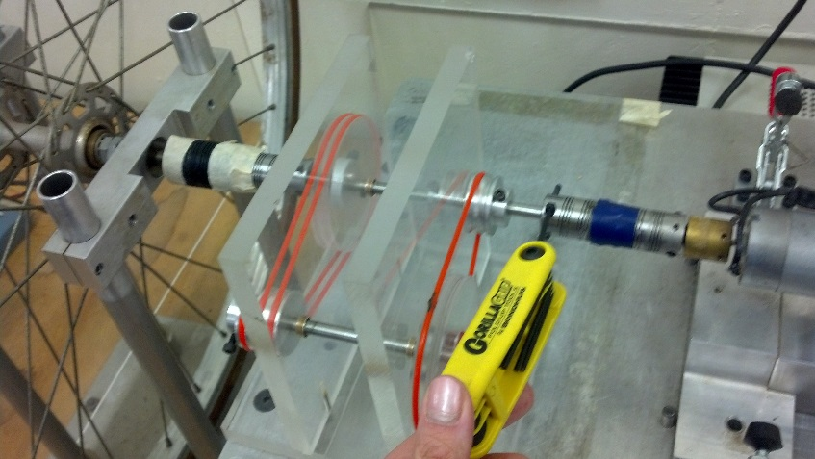

1. **Turn on the power supply, and set the voltage to 24 volts**.

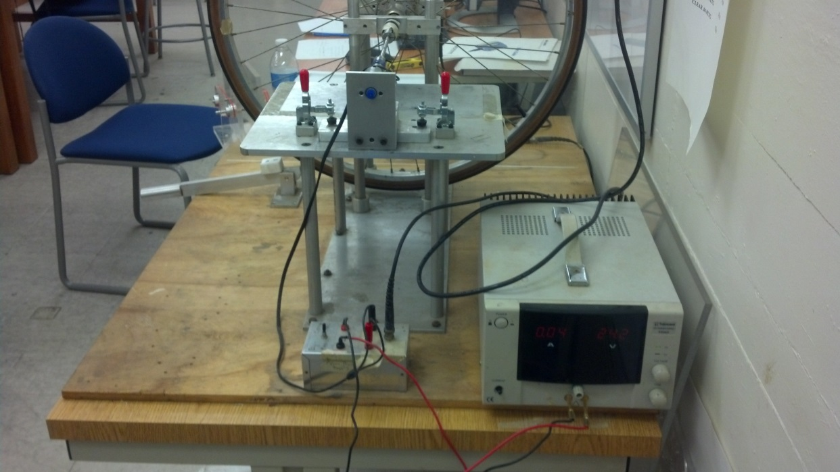Make sure the switch on the control box is set to “computer” mode, which allows the computer to run the motor when “Start” is pressed in LabVIEW. “Bypass” mode turns the motor on directly, regardless of input signals from the computer.

Power supply

Control box

1. **Click the "Start" button on LabVIEW front panel.** This will automatically start the motor and the LabVIEW program to determine your score.

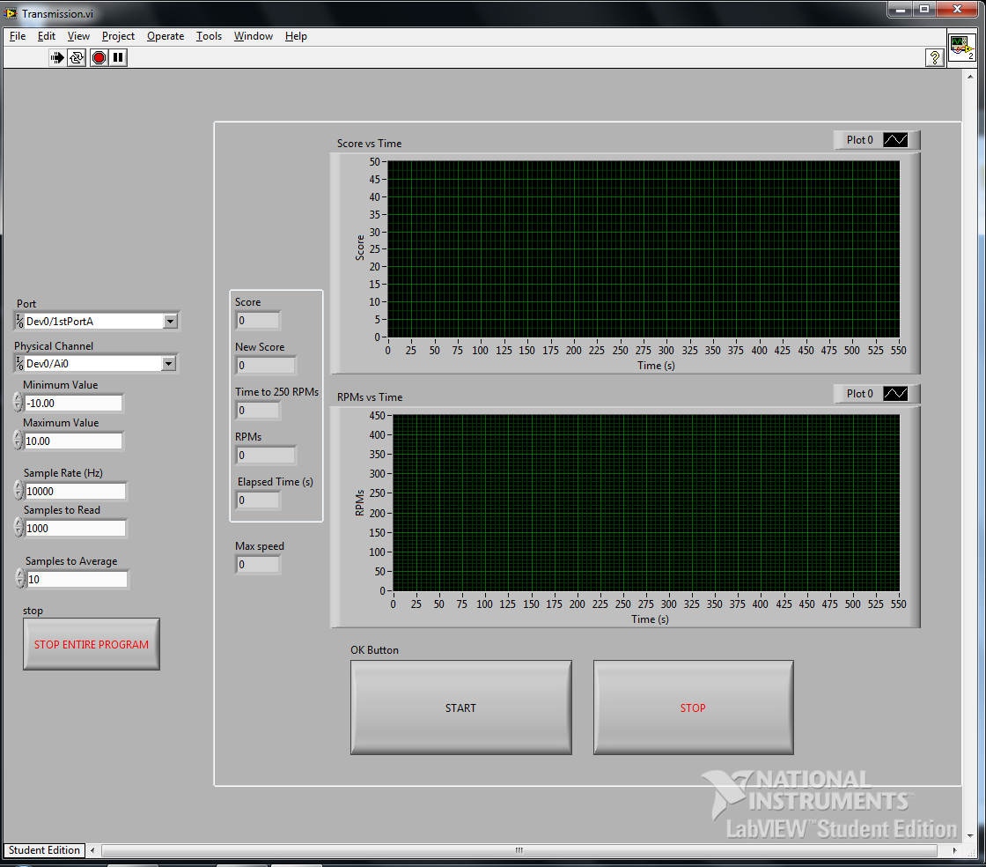

1. **To stop, click "Stop" button on LabVIEW front panel. Note your score. Once you’re done, click the "Stop Entire Program" button to the left.**
2. **To troubleshoot, see the DAQ and LabVIEW documents by the computer. Or email Melissa at** [**mmtanner@caltech.edu**](mailto:mmtanner@caltech.edu)**. Good luck!**