**ME**

14

# Transmission Contest

# _

#### OBJECTIVE

To design and build a single-ratio transmission that effectively couples the rotational power of an electric motor to a rotating wheel. This project serves as an opportunity to design and fabricate a device that requires preliminary calculations, detailed machining, careful alignment, and extensive testing to yield minimum frictional loses and maximum performance in a design competition format.

**WEB REPOSITORY**

Updates to the rules, deadlines, and important contest parameters will be maintained at the class web site.

#### IMPORTANT DATES

###### **Monday/Tuesday May 5 & 6 2014** Preliminary Design Proposal

A summary overview of your design concept will be discussed in a ***preliminary*** ***design review (PDR)***. Bring to the PDR a list of your team members, your team name (if you have one), the "name" of your entry (if you have one), a sketch of your design ideas, and a discussion of the important physical principles and characteristics of your transmission design.

***Tuesday May 13, 2005*** *Analysis*

Summarize and document the Design Analysis that your team carried out in preparing the design of your transmission.

###### **Thursday May 15, 2014** Transmission Contest

Transmissions will be tested during class time (2:30-4:00) in the M.E. Shop.

###### **Tuesday May 20, 2014** Design Debriefing

A 1-2 page summary describing the innovative features of your transmission and evaluating the successes and failures of your design. Did aspects of your design perform better than you had anticipated? Did things go wrong that you didn’t expect? What would you have done differently were you given more time?

**TEAMS**

Students will work in self-selected groups of two or three to design and fabricate one single-ratio transmission. Interactions with other students in the class is highly beneficial; therefore, conversations, calculations, analyses, ideas and tests may be shared among the students, but the transmission design and fabrication must be the effort of an individual group. In the end, the effectiveness of a particular design will depend on how well it is fabricated, tested, and tuned by the group.

#### EVALUATION

The performance of each transmission will be measured ***once*** during the transmission contest. The same constant-voltage power supply and load wheel will be used for all evaluations. The load wheel will start from rest and its speed will be measured by monitoring the output of a tachometer that is connected to the wheel shaft.

A score (S) for each Transmission will be computed according to the following cost function:

S   =   max/T250

where:

max = maximum rotational speed (in rpm) of the wheel (this can

be a peak speed, and need not be sustained)

T250 = time (seconds) required for the wheel to reach 250 rpm

(or the time to reach the maximum speed if it is less

than 250 rpm).

##### CONTEST DETAILS

**1. SAFETY**:

A transmission that is judged to be a potential safety risk to any participant or spectator will be disqualified.

Safety glasses must be worn at all times while testing your design. It is, of course, also mandatory that safety glasses be worn at all times while in the M.E. Shop.

**2. ENERGY SOURCES:**

The power used by the transmission to spin the load wheel is limited to the power supplied by the electric motor. This must be true on an instant-by-instant basis, which means that no appreciable energy from the motor can be stored in any mechanical device other than the transmission, and no other energy storage device (such as rubber bands) can be integrated into the transmission.

**3. TRANSMISSION PROJECT MATERIALS:**

Your transmission must be constructed entirely from materials supplied by the M.E. Shop for this class:

* Plexiglas/Acrylic sheets.
* 1.0-inch diameter aluminum round stock
* 0.25-inch OD (outside diameter) precision ground steel shafting (limit 24 inches per group).
* 5/16” aluminum shafting
* Threaded fasteners (screws) from the M.E. Stock
* 3/32-inch cross section urethane belt (orange-go) material that can be formed into belts of any length
* Other shafting, gears, and bearings that your team can purchase from any supplier, with an upper limit of $75 per team (including shipping and tax).
* Glues and epoxies may be used for bonding.

These materials may be mechanically modified in any way (disassembled, cut, machined, ground, etc.). The project materials ***may not*** be altered chemically (except by glues & epoxies for bonding).

Soldering and Brazing are permitted. Welding is not permitted.

Light machine oil, mineral oil, or vegetable oil can be used SPARINGLY to lubricate. Do not contaminate the evaluation apparatus with your lubricants.

It is permissible to build tools, jigs and/or fixtures to help fabricate your transmission, and also to help prepare it for evaluation. For example, you might want to build a template or other device to help ensure that your transmission is set up "perfectly" before its evaluation.

#### 4. TRANSMISSION SPECIFICATIONS

***Size:***When the evaluation begins, your transmission must fit into a 6” x 6” x 6” volume: that shafts needed to couple your transmission to the motor and wheel couplers can extend beyond these boundaries by a small amount as needed for coupling. Your entire transmission must fit inside the volume at t=0, when electrical power is applied, at the start of the evaluation.

***Mass:*** There is no limit on the transmission's mass; however, you must be able to install/remove it within the allocated time.

***Physical Interaction:*** No manipulation of, or interactions with, a transmission is allowed during its evaluation.

***Installation:*** Six threaded mounting holes are provided to simplify the installation of your transmission. It is recommended that you use at least one of these to fasten your transmission to the mounting platform during the evaluation of your device. Both the motor and wheel have 1/4-inch OD shafts and flexible couplings to connect the motor and wheel to the 1/4-inch OD input and output shafts of your transmission. Note that the transmission may be placed anywhere within the 6 x 12 inch outline on the mounting platform at the start.

**5. SPATIAL RULES:**

Each transmission must be designed to functionally interact with nothing other than: the mounting platform, the motor shaft, and the wheel shaft.

**6. EVALUATION APPARATUS:**

Flexible couplings with 1/4-inch ID split clamps are provided on both the motor and wheel shafts. These flexible couplings can accommodate ~0.008-inch of radial misalignment, and 3o of angular misalignment. They require 3/~8-inch of axial length for clamping to the input and output shafts of your transmission. The following diagrams show the approximate mounting geometry. But you should take measurements on the apparatus for precision.

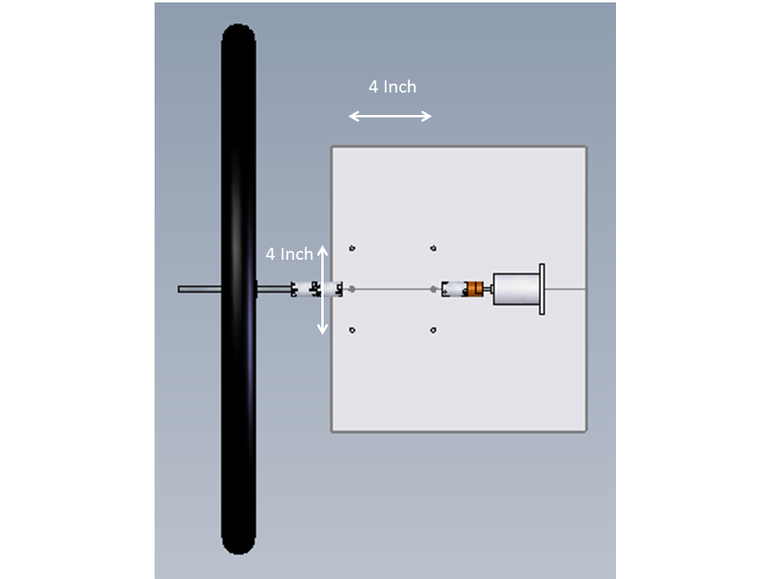

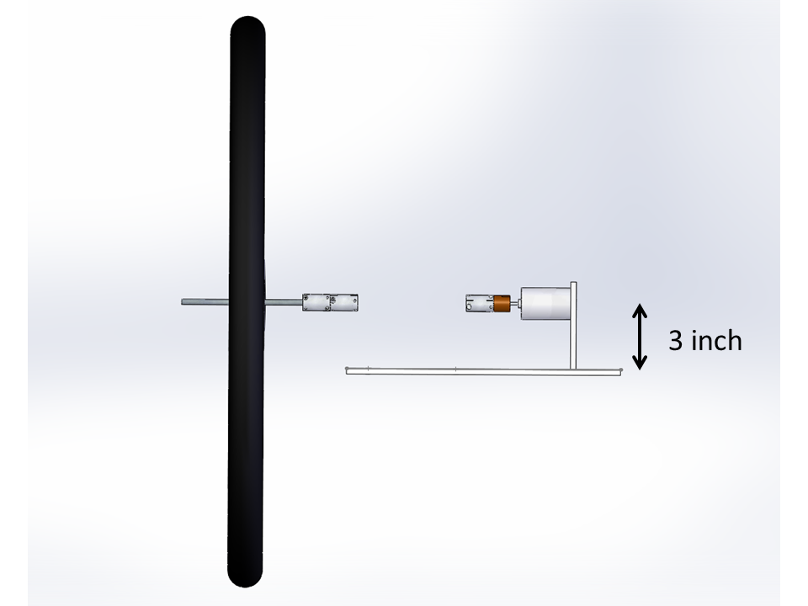

The load wheel has the following experimentally measured performance properties: (note that these are approximate, limited by our measuring capabilities).

|  |  |  |  |  |  |
| --- | --- | --- | --- | --- | --- |
| **Speed** (rpm) | 76.2 | 156.6 | 232.8 | 301.2 | 337.5 |
| **Drag Torque** (N-m) | 0.00905 | 0.02450 | 0.04880 | 0.07790 | 0.09840 |

**Wheel Model:** A curve fit to the measured drag torques has the following form (w is the wheel speed in radians/second):

Drag Torque [N-m] = 7.29390 x 10-7 w3 + 2.91430 x 10-5 w2 + 8.37900 x 10-4 w

The rotational inertia of the load wheel is approximately: I = 0.27 [kg-m2]. The rotational inertia of the motor is approximately: I = 45 [g-cm2]

**Motor Model:** The motor performance at its normal operating voltage of 24V is characterized by the following (approximate) specifications:

Stall Torque (Ts) = 0.287 N-m

No-Load Speed (wo) = 4550 rpm

***NOTE: These parameters may be subject to change. Please check the web site for updates.***

**8. TIME:**

The timing of the evaluation procedure is:

* 45 seconds to set-up your transmission, starting from when your group is called to start.
* 240 seconds maximum duration of each evaluation starting with the application of power. That is, if your device does not reach its top speed by 240 seconds, then we will evaluate your performance based on the data obtained at the end of this period. No action of the transmission is permitted prior to the application of electrical power to the motor.
* 30 seconds to remove all of your transmission after the evaluation.

**9. GRADING:**

Remember winning isn't everything. Having the transmission with the highest "score" is not the primary goal of this activity. The main aim is to learn something about engineering design, and applying the engineering material that you have learned in your other classes to a design problem. A separate handout will explain the grading process.

1. **PROJECT TESTING:**

The contest apparatus will be available (in the shop) for student testing at least 1 week prior to the contest date. The apparatus is available for measurements during the entire period of the project. Intentional damage to the evaluation apparatus will result in disqualification.